# Running the Template

Now that you’ve created your CloudFront template, you’ll want to install the AWS Command Line Interface, configure it, and deploy the template. Step by step guidance on each of these activities is provided below.

## Installing the AWS Command Line Interface (CLI)

You’ll begin by downloading the AWS Command Line Interface (CLI), using the guidance located here (http://docs.aws.amazon.com/cli/latest/userguide/installing.html)

After installing the CLI, you’ll want to confirm that it is installed properly. You can do this by typing the following at a command prompt -

aws –version

The message that is returned should resemble the one below –

aws-cli/1.10.17 Python/2.7.9 Windows/8 botocore/1.4.8

## Configuring the AWS Command Line Interface (CLI)

Now that the CLI is installed, you’ll want to configure it with your security credentials and the default region to use with it. You’ll need your Access Key ID, Security Access Key, and the id for your preferred region. The first two can be found in the identity and access management part of the console, which is located here - <https://console.aws.amazon.com/iam> . The names of the regions in which cloud formation is supported is located here - <http://docs.aws.amazon.com/general/latest/gr/rande.html#cfn_region>.

Executing the following command line will initiate the configuration process -

aws configure

Once the environment is configured, you’re ready to deploy the template.

## Deploying the Template

Amazon refers to the deployment as a ‘stack’, so using the AWS CLI you’ll use the ‘create-stack’ call to initiate the deployment of your template. You’ll provide three values ‘stack-name’, ‘template-body’ and ‘parameters’

|  |  |
| --- | --- |
| stack-name | This is a name for the stack you’re creating. It must be unique to the region. |
| template-body | This is a pointer to the content of the template. The example below is valid when the template DeploymentTemplate.template is in the same folder where the AWS CLI is being executed. |
| parameters | This is a pointer to the file that contains the input parameters for the template. |

The following command line will create a stack named “CrossCloudSample” and populate it with the content of the template associated with this article, “DeploymentTemplate.template.” This command line assumes the command line is being run in the same directory as the template.

aws cloudformation create-stack --stack-name CrossCloudSample --template-body file://./DeploymentTemplate.template

Executing this command should initiate the creation of the stack, and the CLI will provide you a globally unique identifier (GUID) for it.

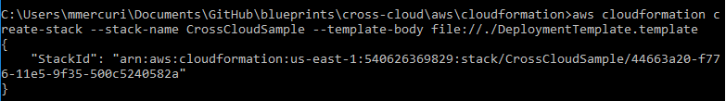

## Confirming the Deployment is Complete

You can confirm the state of the deployment by navigating to the AWS Console in your web browser (<https://console.aws.amazon.com/console>). Once there, double-click on the Cloud Formation page.

Once deployment is complete, your browser window should resemble the one below.

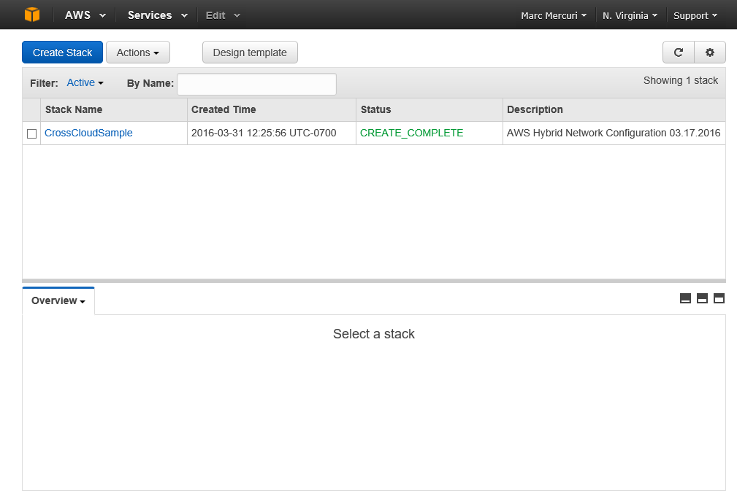

Note –If you don’t see your stack listed on the Cloud Formation page, it may be because the region selected in the browser doesn’t match the region you identified when configuring the AWS command line interface. If the region in the upper right corner of the page doesn’t match the one you used with the AWS CLI, you can click on it and select the appropriate region.